**EXPERIMENT-8**

**DATE: 29-09-2025**

**AIM:**

To create a virtual hard disk and allocate the storage using vm ware workstation

**PROCEDURE:**

**STEP 1:** go to VM Ware Workstation.

**STEP2:** Right The VM and Go to the Settings

**STEP 3:** Add Hardware Wizard and Select SCSI and CLICK NEXT.

**STEP 4:** Create New Virtual Disk.

**STEP 5:** Select The Disk Size As2.0 and Split The Virtual Disk into Multifiles.

**STEP 6:** Give The Name and CLICK The FINISH.

**IMPLEMENTATION:**

**STEP 1:GOTO VM WARE WORKSTATION**

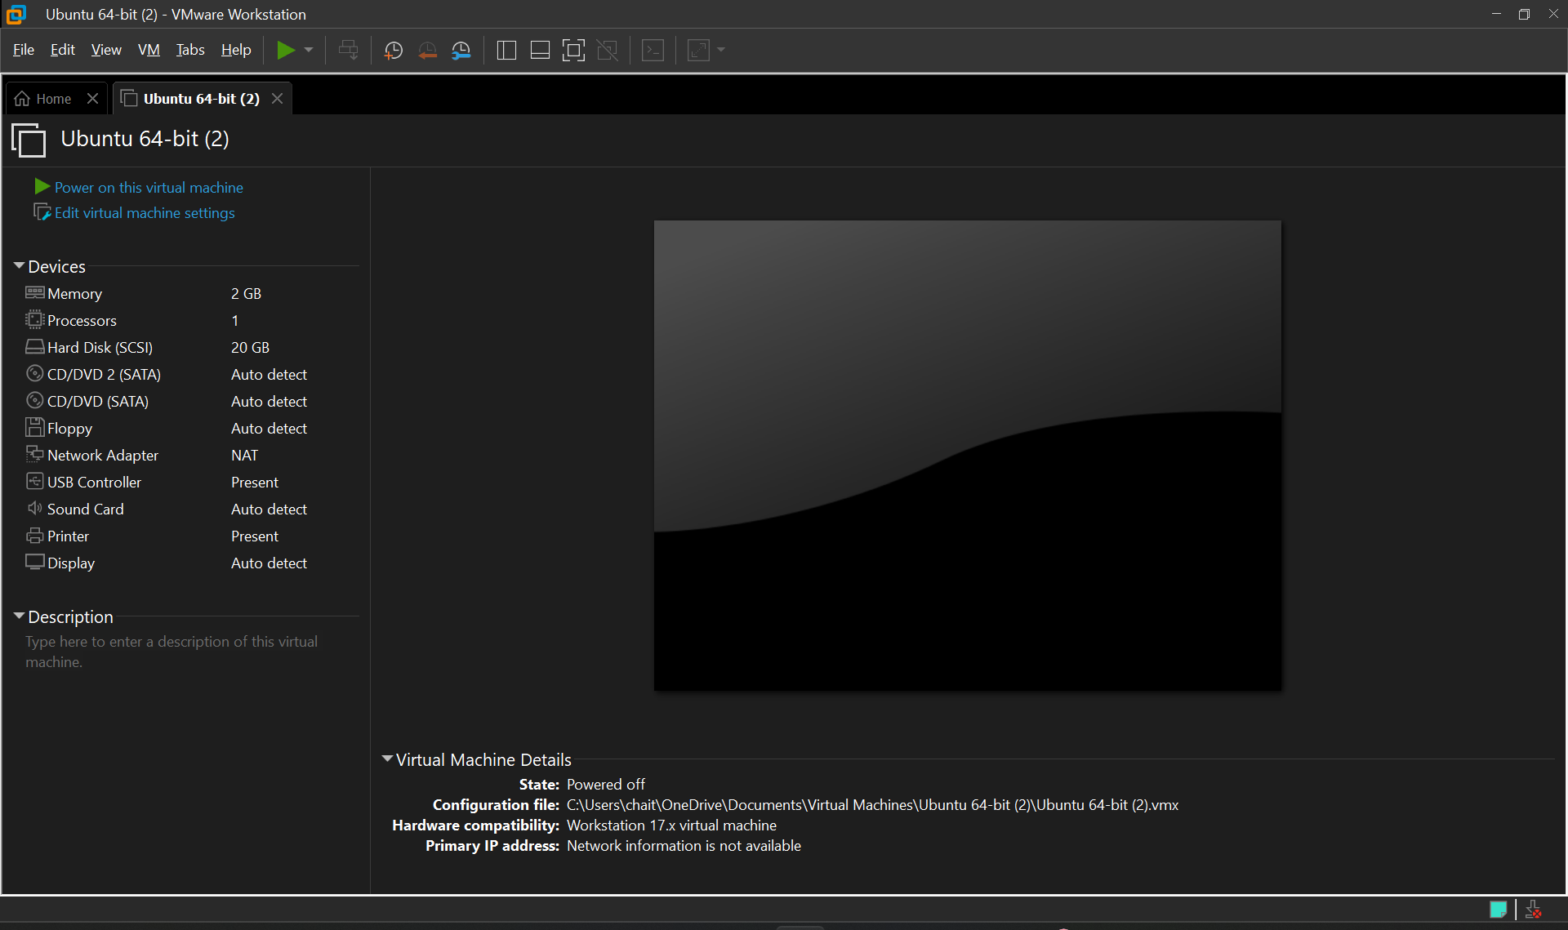

**STEP2: RIGHT CLICK THE VM AND GOTO THE SETTINGS**

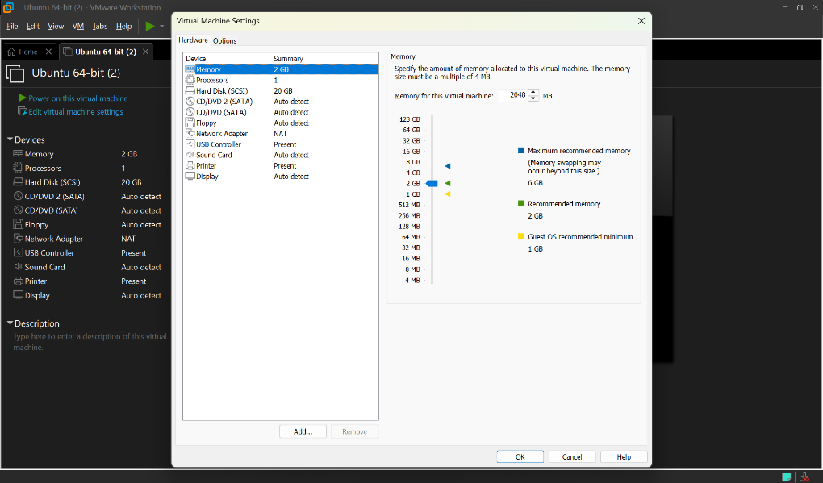

**STEP 3: ADD HARDWARE WIZARD AND SELECT SCSI AND CLICK NEXT**

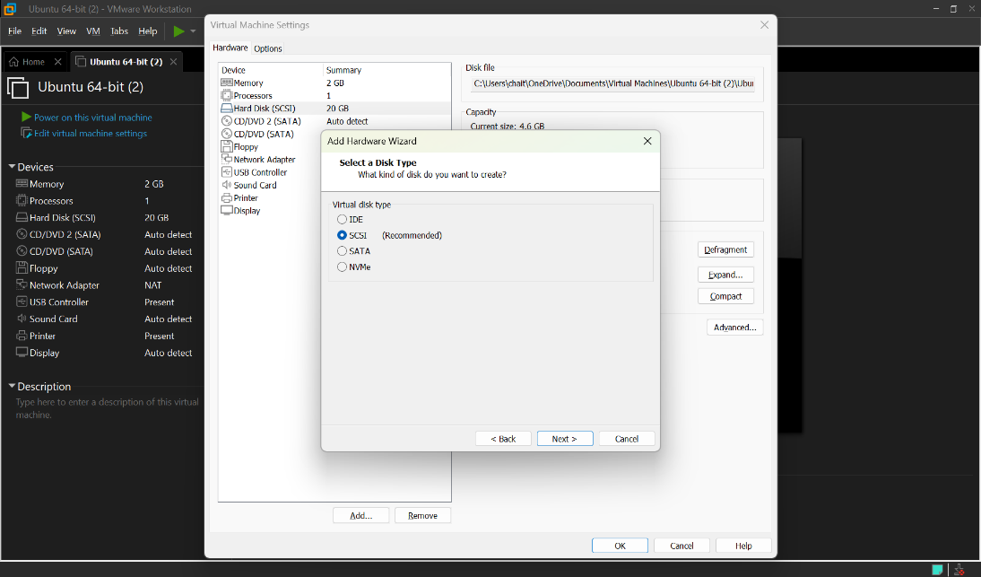

**STEP 4: CREATE NEW VIRTUAL DISK**

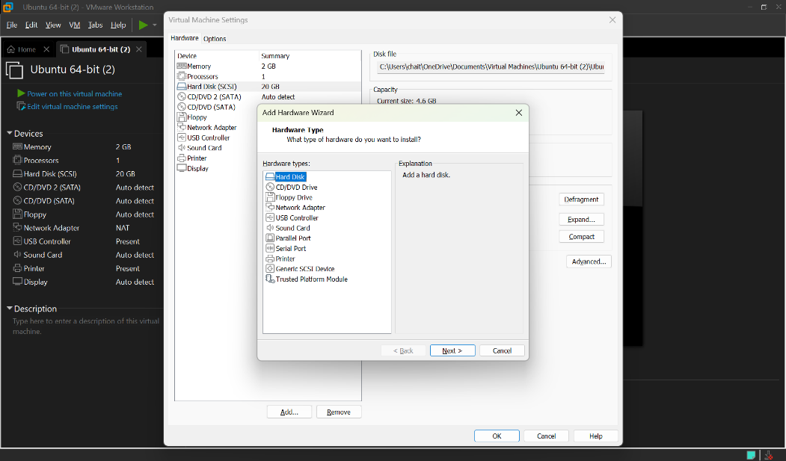

**STEP 5: SELCT THE DISK SIZE AS 2.0. AND SELCT SPLIT VIRTUAL DISK INTO MULTIFILES.**

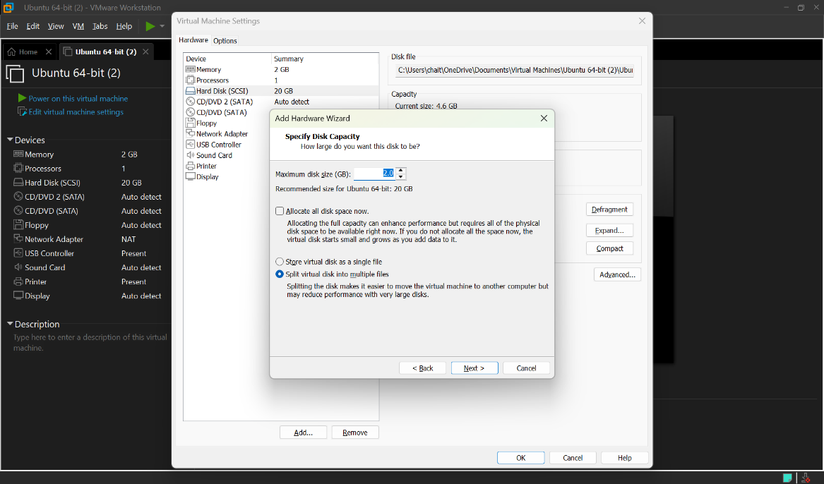

**STEP 6: GIVE NAME AND CLICK THE FINISH**

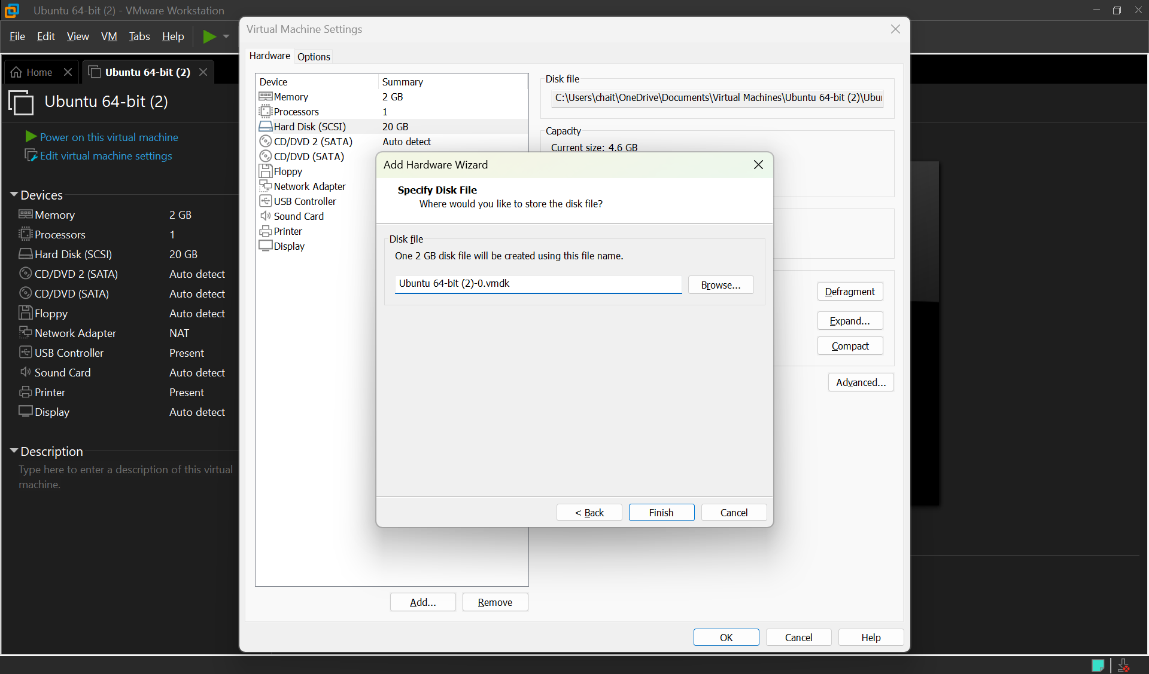

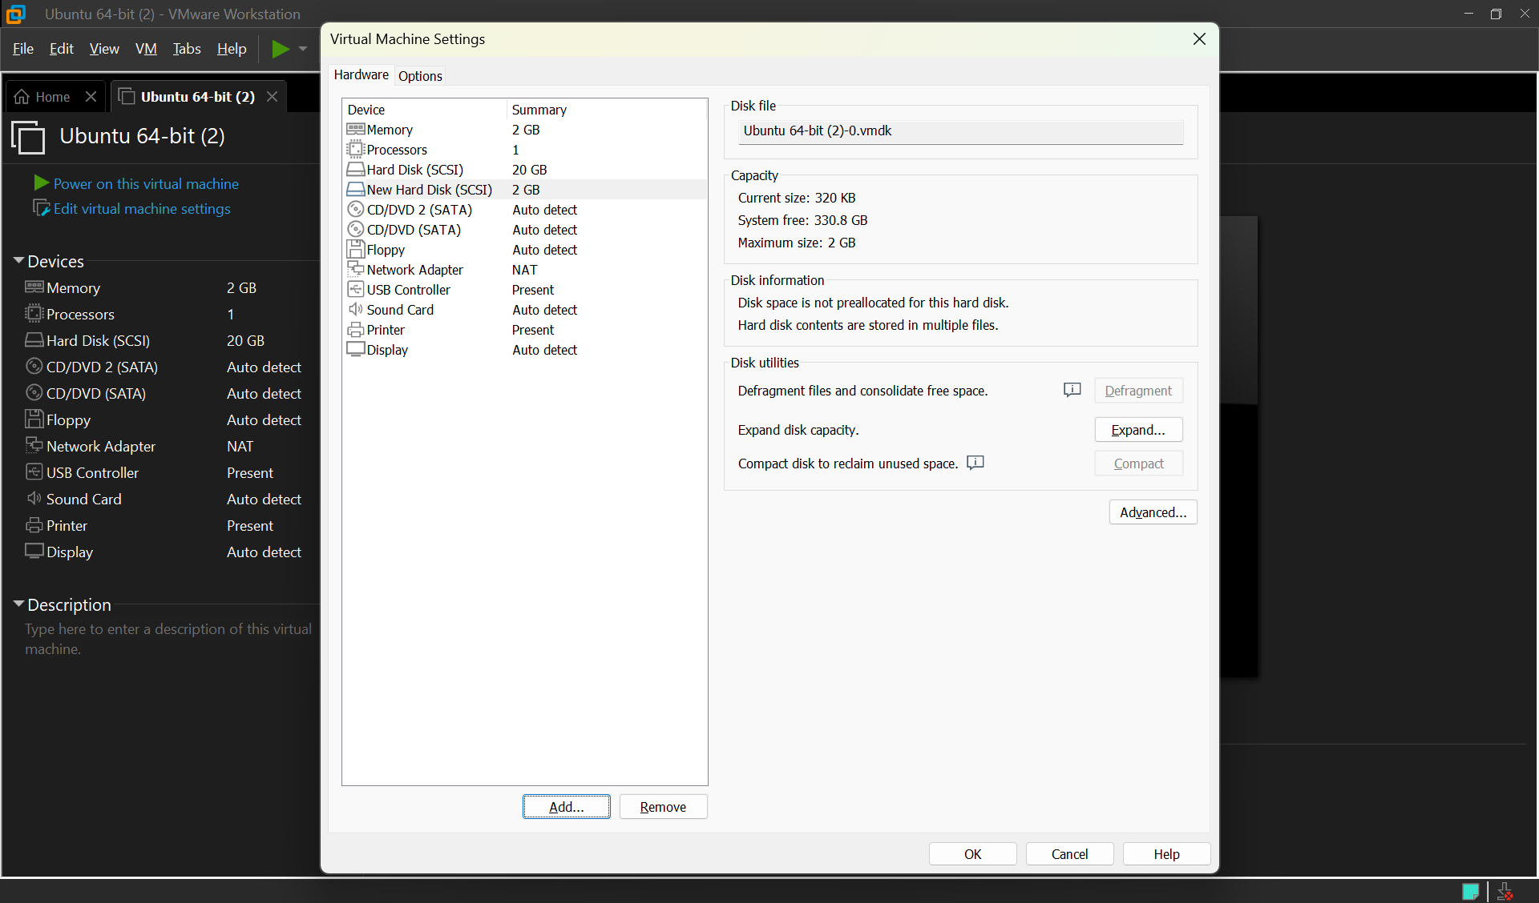

**RESULTS;** successfully created a virtual hard disk and allocate the storage using vm ware workstation